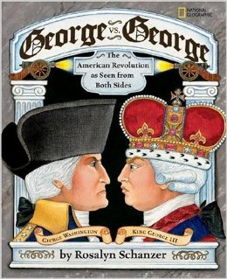
Activity One: Reading Opposing Perspectives to Form an Opinion
This activity focuses on students ability to comprehend two viewpoints that are at odds with each other and use these viewpoints to form their own opinions supported by textual evidence. According to Dartmouth's discussion of academic writing, "Academic writing should present the reader with an informed argument. (Gocsik, 2005). This comprehension strategy allows children to practice that skill.
Since my dream classroom would be a middle level social studies position, I focused my lesson on some of the Oklahoma PASS standards for both Reading and Social Studies. Killing two birds with one stone shall we say. I used the text George vs. George: The American Revolution as Seen from Both Sides by Rosalyn Schanzer, however you could use any text or article that lays out two viewpoints on an issue. You begin by introducing the topic at hand and asking students to observe and record the two opposing viewpoints in a provided chart. Stop periodically at points where opinions are made and ask students to identify and record those opinions. Once you have read through the entire text, or through your selections of the text, give students about 5 minutes to write down their own personal opinion of the issue after reading the selection supported by facts from the text. Once they have written down their opinions, have them turn and talk about them with a partner or at their table. If time allows, do a whole-class share so students can hear their classmates' opinion.
This activity lends itself particularly well to social studies. There are always two sides to any historical event; unfortunately, many students are not taught both sides but rather are taught to see just the side included in their social studies text. This does not allow for students to form their own opinions of the historical event, rather they are forced into rote memorization. Giving them both sides and allowing them the freedom to determine their thinking is important. It also requires comprehension of both sides of the argument, critical thinking skills, as well as allows students to develop empathy and understanding of another student's opinion even if it differs from their own. I have included a link to my lesson plan on this activity and a link to the chart I created to coincide.
Activity Retrieved From: Strategies that Work: Teaching Comprehension for Understanding and Engagement, Second Edition by Stephanie Harvey and Anne Goudvis

Activity Two: Interpreting Comic Strips for Comprehension
I really wanted to find a comprehension strategy that I could use to specifically support ELL students. All students need to be able to use context clues occasionally to support them in their reading. This is an especially important skill for ELL students to help them when they come across a word that they do not know. There are many ways to help these students become better readers and enhance their comprehension. Some examples are sounding out words, chucking words, as well as context clues.
Context clues alone will not always be enough support for your ELL students. That is where this strategy comes in. Illustrations are oftentimes looked over in a book when comprehension is the main goal. However, visual literacy, using and understanding the images the author included, can help your ELL students dramatically. For this strategy, find some comic strips that have text that could be somewhat challenging for ELL students. Look at cartoons such Peanuts, Calvin and Hobbs, and Garfield that have kids or animals in them and little "adult" content.
Begin by covering up the words on the strip and having your students use the pictures to infer what is happening. If you have time, have them write down what they think the dialogue is. After they have done this, reveal the text and have them read it. Since they have been shown the pictures, they already have some schema about the events presented. They may not know all the words and that is okay. The important part is that they are beginning to learn strategies to help aid their comprehension later on.
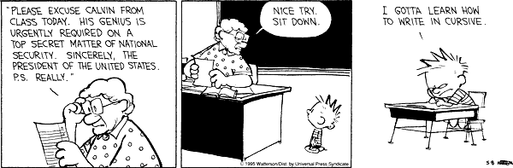
Activity Retrieved From: Fun-Tastic Activities for Differentiating Comprehension Instruction by Sandra K. Athans and Denise Ashe Devine

Activity Three: Inferring and Questioning to Understand Historical Concepts
As you can tell, I love Social Studies and History a lot. This is another comprehension lesson plan that is cross-curriculum for Reading and Social Studies. I would use this activity as an introduction to an exploration unit in Social Studies. The mentor text for this lesson plan is a wonderful book called Encounter by Jane Yolen. You would begin by creating a chart that had the title of the book at the top, some blank space and then two columns. Your first column would be labeled "Questions (I wonder)" and your second column would be labeled "Inferences (I Think)." I would make a large mentor chart for the instructor to model on as well as individual charts for the students to write on and keep in their social studies folder.
Begin by helping students activate their background knowledge (schema). Do a whole-class discussion of what students already know, or think they know, about Christopher Columbus and exploration. do not take much time here, less than five minutes is more than enough. Write down everything the students say on the large mentor chart and have them write these ideas on their own charts. After this discussion, read the first page of the story and model your own questions and inferences on the large chart. Do not forget to include questions and inferences about the illustrations to teach visual literacy. Continue through the story stopping periodically to have students share their questions and inferences as well as adding some of your own.
Since this is a somewhat challenging text, the question and inference strategy works really well to support comprehension of the text. ELL students might find this more challenging than English proficient students, so be sure to pay extra attention to their questions and monitor their comprehension closely. At the end, close the lesson by reiterating that what students have been doing by asking questions and making predictions is really inferring what will happen next. Encourage them to keep their list of questions close by throughout the unit on exploration and keep adding questions throughout the entire unit.
Activity Retrieved From: Strategies that Work: Teaching Comprehension for Understanding and Engagement, Second Edition by Stephanie Harvey and Anne Goudvis

