Go Fish Letters
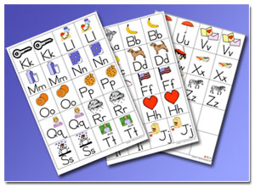
Materials:
- Picture Cards with Letters of the alphabet and pictures cut into playing cards
- Make your own or download and print free Do2learn alphabet cards.
- Make the cards larger and more durable by gluing each alphabet card to an index card.
Setup:
Each player is dealt 6 cards and the remaining cards are placed face down in a pile.
To Play:
Play is exactly like traditional Go Fish, except instead of matching numbers, players match the sounds of each letter, not the name. For older children, use cards that only have letters on them and no pictures. Download and print cards without pictures here.
Other variations :
Play Memory with the alphabet cards. Cards are laid out in a grid face down, and players take turns flipping pairs of cards over. On each turn, the player will first turn one card over, then a second. If the two cards match, the player scores one point, the two cards are removed from the game, and the player gets another turn. If they do not match, the cards are turned back over. The object is to match more pairs of cards than the opposing player.
Make a Matching folder activity with the cards. Glue one of each letter to the inside of a file folder. Have your student match the remaining letters to those glued on the folder. Make this a more durable activity by laminating the folder and using velcro to affix pairs together.

