Megan Gregory
26 March 2018
Professor Sean Smith
Field Interview Assignment

Interview Paper
For this assignment, I interviewed Maschielle Elaine Stahlman Brakefield. What led me to interview this particular educator was through suggestion of my husband who commended Mrs. Brakefield as one of his favorite teachers growing up. At the time, she was a general education teacher but is currently a 7th and 8th grade ELA Special Education Teacher at Mayfield Middle School which is located in Oklahoma City, Oklahoma. I feel connected to this educator due to the sincere and positive experiences my husband expressed. When interviewing Mrs. “B” she explained how she began her career, what she has learned as well as advice for me as a future special educator. She began her career as an early childhood educator teaching kindergarten, and her bachelor’s degree is in elementary education. This is similar to my path, as I studied elementary education while achieving my undergraduate degree. As I conducted this interview, I learned more not just about Mrs. B but also of what I hope to achieve throughout my teaching career.
Mrs. B took the Oklahoma state certification test to become certified in early childhood at the recommendation of an administrator to make herself more marketable as a teacher. The explanation ties to how teachers are a growing need in a variety of areas. I have also been told to become certified in as many areas as I can so that I can get my foot in the door at whichever school I attach my career. Mrs. B expressed that as a general education teacher, she always worked well with students and families who have exceptional needs so as she began her special education instruction, her classes were regularly chosen to be inclusion classes for special education students. The progression from early childhood and elementary education was a natural move into special education.
Mrs. B has been at her current position for three years, and this is her 9th year as a special education teacher. Before, she taught for 14 years in Yukon, Oklahoma. Eleven of these years, she was a general education teacher (two of which, she taught my husband,) and for 3 years she was a special education teacher. Mrs. B had wonderful insight as to what it is like to deal with paperwork, personnel issues, and management while also ensuring the success of her instruction and students. In Mrs. B’s years of teaching, she has taught kindergarten, 2-4th grade general education (all subjects), k-5th grade special education (all subjects) as well as 7th and 8th grade special education ELA. I connect this to my goals as an educator because I hope to gain experience from the general education classroom as I prepare for a special education one.
Mrs. B is certified in Early Childhood, Elementary Education, Language Arts, Social Studies, Mild-Moderate Special Education, Severe-Profound Special Education, and is a 2010 National Board Certified Teacher in Literacy. My hope is to become certified in Elementary Education, Middle Level Math, Language Arts, and Social Studies, Secondary Education, and Mild-Moderate Special Education. Mrs. B attended college at Southwestern Oklahoma State University where she received her B.S. Elementary Education and then Southern Nazarene University where she achieved her M.Ed in Curriculum and Instruction. She advised me how important it is to make myself marketable with not just a variety of certification areas but also with a master’s degree.
Further, I learned valuable information from this interview such as the importance of having a teaching philosophy. Mrs. B’s teaching philosophy is “Teaching is about building mutually respectful, child-centered, positive relationships with students, families, and colleagues.” My philosophy is similar in that it is my responsibility to help others, specifically my students as I collaborate with students, families, and colleagues to create social advocates that help build a positive, respectful environment. Our minds are even more alike in that she wanted to major in special education as a freshman in college, but her advisor talked her out of it. For some reason, some advisors and parents alike seem to think that a teaching career does not promise financial stability. Some also think that special educators have such a high burn-out rate and that we would have a more varied range of career opportunities if we went another route. In reflecting upon her career choices (as well as mine), we are more than happy with the career path we have chosen.
Mrs. B chose to be a special educator because there are many teachers and nurses in her family. She chose teaching as a profession because she admires the craft and has a great respect for educators. For me, my choices have been based off of my experiences. I am an advocate for those who are different. Though each person is unique, my goal is to support them by providing an equal education and supportive learning environment. In Mrs. B’s classroom, they have a family environment. She uses a mixture of Great Expectations and Discipline with Love and Logic to set classroom expectations, and she applies consequences when necessary. Mrs. B has found in the transition from elementary teaching to middle school teaching that there is typically less visually appealing environments. Many middle school classrooms appear more institutional than elementary classrooms so she makes her classroom more visually appealing using decorations, anchor charts, student work, goals, and data trackers. This explanation of what Mrs. B does specifically to support her students gave me ideas for how my classroom will be designed in the future.
As our interview progressed, we discussed the different measurements that Mrs. B uses to ensure student success. She uses several different curriculum based measurements to ensure that the students are learning to the best of their ability after they are placed on an IEP. Mrs. B used unit tests that are modified depending upon the students’ needs. They use the AIMS web program to track learning progress in reading and math as well as a remedial program. She listens to her students read aloud one on one 2-3 times a week. They work in very small groups, as her largest class is 11 students with mild/moderate disabilities. The small groups are Mrs. B’s favorite, and she believes this is the best way to teach and assess learning. Here, I made connections with the various types of co-teaching we can implement in our classroom as well as the models and measurements we can apply to assess instruction and evaluate the students.
For interventions, Mrs. B uses Literacy First, and DIBELS reading to remediate reading. This brought up the case studies we have been studying throughout this course, and she expressed how applicable the information we have learned is to the actual classroom. Also, Mrs. B explained how her students work on vocabulary and grammar every single day at 2-3 grade levels below the students’ actual grade level. This is because not only are her current students mild/moderate, they also are 90% ELL (English-Language Learners.) Though we did not have an ELL student in our case studies, we did have some that have been assessed through DIBELS and some that had vocabulary/grammar struggles. It was reassuring to hear Mrs. B explain what she deals with on a daily basis and comparing her knowledge to that of which I am gathering from this course.
As for evidence-based practices that Mrs. B uses to address learning, behavioral, and/or physical needs of the student with a disability as well as his/her nondisabled struggling peers, Mrs. B uses Marzano as a district-wide model for setting learning goals and tracking progress. It is used as the method of teacher evaluations as well. She co-teaches two inclusion classes mixed with disabled students as well as their peers. This is a very effective method of teaching and the school has seen the highest growth in the bottom 25% district-wide. Students also track their own data and set their own learning targets, which increases their “buy-in.” Further, there are a variety of forms of monitoring that Mrs. B applies (tests, records, etc.) Students are monitored based on their goals and objectives on an annual basis during their subsequent IEP. They are also monitored weekly through progress monitoring in reading and math. Through collaboration, and to meet the needs of the students, Mrs. B discussed how they are very fortunate to have a great co-teaching/inclusion program at the school. She has a professional learning time with the general education teachers, which is when they work together twice a week to monitor goals and plan lessons for differentiated instruction.
After discussion of collaboration, strategies, etc., moved into the challenges that Mrs. B has been faced with and what have she learned. One of the biggest challenges Mrs. B faced during her career in education was the increasing demands placed on teachers, and this is still occurring. For instance, they lost a special education teacher last year due to budget cuts resulting in Mrs. B being responsible of teaching two grade levels. Now, she is doing the work of two teachers this year with no compensation other than the satisfaction of a job well done. I learned from Mrs. B that teaching is a very stressful profession for many reasons. However, she continues to find great personal satisfaction and joy in working with her students.
In Mrs. B’s opinion, the rewards of being a special education teacher are that she has found great joy in teaching students who learn differently than their “non-disabled” peers. Having high expectations for students who are convinced they cannot learn or who have had very little academic success is only to find out they can learn is professionally and personally rewarding. As we moved from joy in students, we talked about the types of interactions she has with parents and family members. In recent years, the back to school nights and parent/teacher conference attendance has increased by over 50%. In this data, Mrs. B showed me that family/teacher relationships are another rewarding aspect of her job.
Moreover, to better understand the needs of students with challenges (identified or not identified as a disability), Mrs. B takes the time to get to know the students on an individual/personal basis. This is the “key to success.” Mrs. B endeavors to find out as much as she can about their backgrounds, their likes/dislikes, learning styles, hobbies, etc. It is important to schedule out at least twice a week to spend time getting to visit with each other. On top of getting to know the students to tailor instruction, Mrs. B continues to enhance her knowledge of these students, what their specific needs are, and how to best support them by reading. She relies on experts in the field of education as well as disabilities such as research on practices, measurements, instruction, models, and other components. In response to her findings, Mrs. B has a variety of specific instructional and behavioral practices in place. For behavior, Mrs. B uses Great Expectations and Discipline with Love and Logic, and natural consequences are in place for inappropriate behavior. Mrs. B says she very rarely has discipline issues which cannot be handled within the classroom environment. For instructional practice, she collaborates with other teachers on units and works with students, families, and colleagues to create daily goals and objectives posted in the classroom as “I can” statements.
In Mrs. B’s experience, what works best for the students she currently supports is: communication, respect, acceptance, continuity, discipline and “lots of love!” I hope to have a similar classroom full of the discipline, care, and support that Mrs. B has. More so, I wish to obtain the type of setting and environment she has for her classroom. This is a classroom that is enjoyable to be in, neat and tidy, there is a place for everything and everything has a place. Additionally, they have a classroom library and supplies that students have access to on a daily basis. As we neared the end of our interview, Mrs. B made sure to tell me that one of her greatest joys is mentoring and working with new teachers and educational leaders. Working with new teachers keeps her young, energized, and gives her hope for the future of education.
In serving students who have disabilities, Mrs. B’s perspective has evolved over the years. Serving the students has changed her perspective by making her even more compassionate than she was before she began teaching special education. After completing this interview, I not only gained insight to what life is like for this particular special education teacher, I obtained knowledge and perspective for what to expect once I have my own special education classroom.

Interview Questions
- Please state your full legal name and current school.
- What is your current position?
- How did you arrive at this position?
- How long have you been there?
- Where were you before?
- What age/grade levels have you taught?
- In what areas are you certified and/or experienced?
- Where did you attend college?
- What is your philosophy of teaching?
- Have you always wanted to be a special education teacher?
- What made you choose this profession?
- How do you interact with your students?
- What does your classroom typically look like?
- What do you do to meet the needs of ALL learners (especially those with disabilities)?
- What interventions do you use?
- What evidence-based practices do you use to address learning, behavioral, and/or physical needs of the student with a disability as well as his/her nondisabled struggling peers?
- What forms of monitoring do you apply (tests, records, etc.)?
- How do you collaborate (and who with) to meet the needs of the students?
- What challenges have you been faced with and what have you learned?
- In your opinion, what are the rewards of being a special education teacher?
- What types of interactions do you have with parents and family members?
- How have you gone about better understanding the needs of students with challenges (identified or not identified as a disability)?
- How do you continue to enhance your knowledge of these students, what their specific needs are, and how to best support them?
- What specific instructional and behavioral practices do you have in place?
- In your experience, what works best for the students you currently support?
- What type of setting and environment do you have for your classroom?
- How do you continue to evolve as an educator?
- What research do you (or did you) participate in as you learned to become an educator?
- How has serving students who have disabilities changed your perspective?
- Do you have any personal ties to special education?
- What advice do you have for me as a future special education teacher?

Screenshots of Professor Sean Smith’s Feedback
(1/2) 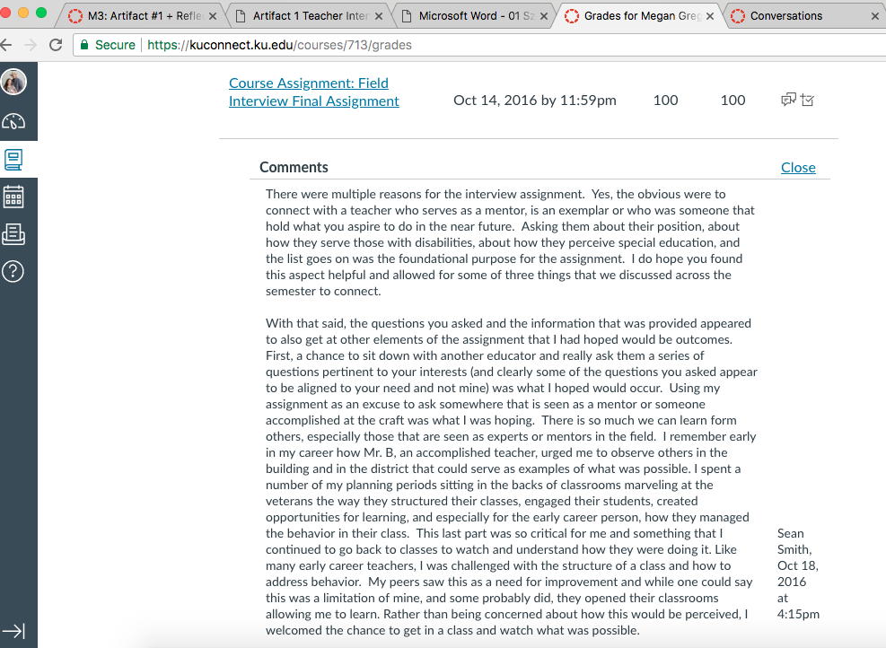

(2/2) 