Final Paper (BIP) and Checklists 1-5 (screenshots attached of professor feedback OR highlighted in blue lettering)

Megan Gregory (Group 3 SPED 743)

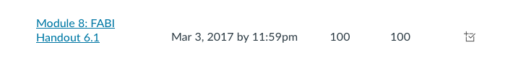
Behavior Intervention Plan

Student Name: M.A Student ID: Click or tap here to enter text.
School: NRH Date of Birth: November 22, 2006
Current Grade Level: 4TH Grade Special Education: ☒ Yes ☐ No
Gender: Male Disability Eligibility: ID
Parent(s): Lena Elhamad Parent(s) Contact Number: Click or tap here to enter text.
Date of Assessment: Click or tap to enter a date. Classroom teacher: Victoria Corte- SPED Teacher
Persons conducting the assessment:
Role: ☐ Classroom teacher ☒ SPED Teacher ☐ Teacher (Other) ☐ Teacher (Other)
☐ School Psychologist ☐ Counselor ☐ Behavior Specialist ☐ Intern
☐ University Student ☐ BCBA/ ABA ☒ Other: University of Kansas team mates

Behavioral Definitions
Target Behavior:
Off task behavior is when a student is distracting to peers and teacher in classroom, failing to maintain focus and easily distracted. Examples of off task behaviors include interrupting teachers, blurting out in the middle of class, failing to complete class assignments and working well in a small group setting. Non-examples of off task behaviors include completing class assignment without reminders, maintaining focus and do not distract peers, sitting quietly when teacher is teaching.
Replacement Behavior:
On task behavior is when the student engages in any behavior for any period of time that matches the ongoing classroom instruction such as paying attention to the teacher, silently working on homework, or actively participating in group work or class activities. Non-examples of this would be wandering the room, talking to neighbors without permission, or sitting silently without being engaged in assigned tasks or teacher instruction.
Rationale for Replacement behavior:
We want to increase the likelihood of this behavior so that the student can appropriately engage not just in classroom instruction but also daily life.
Baseline Statement:
Four observations were conducted. The range of rate for all 4 observations was 0.23-0.4/min. There was an IOA calculated for one of the observation. The IOA= 90%

 | Positive Reinforcement  (Access Something) | Negative Reinforcement  (Avoid Something)
Attention | Direct Observation: A-B-C Data:  Student off task, looking for others to interact with him. 1.1, 1.2, 2.1, 2.3, 3.1, 4.1  Teacher Interview Questions: 4A,9B,15A,15B,20A,20B | Direct Observation A-B-C Data:  Student off task, not paying attention to instruction. 3.2
Tangibles  Activities | Click or tap here to enter text. | Teacher Interview Questions: 4C, 9C  Direct observation A-B-C Data:  1.1, 2.3, 3.1, 3.2, 4.1
Sensory | Direct A-B-C Observation:  2.2 | Click or tap here to enter text.
Source: Umbreit, Ferro, Liaupsin, & Lane (2007).

Rating Scales Summary Statement:
N/A
Outcome of Function Matrix: Hypothesized Function:
Hypothesized Function: When student is working independently during Math and ELA, he exhibited off task behavior to access teacher and peer attention (positive reinforcement attention) to avoid independent work activities (negative reinforcement: escape from activity).

Functional Behavioral Assessment:
Determining the Intervention Procedure

☐ Method 1: Teach the Replacement Behavior
☐ Method 2: Improve the Environment
☒ Method 3: Adjust the Contingencies
☐ Method 1 & 2: Teach the Replacement Behavior and Improve the Environment
Adjust  Antecedents | - Monitor student when he enters the classroom.  - Remind all students of the classroom on-task rules.  - Tell other students to ignore anyone who does not follow the rules.  - Have student go over the rules and define how he will behave.  - Give student a more specific and additional reminder before he starts his independent/group work.  - Seat student next to peers that are more likely to ignore the target behavior.
Reinforcement  Rates | - When the student demonstrates on task behavior, the teacher will provide positive feedback and praise.  - The student is given 2 break cards at the beginning of every class. He is allowed to put the break card on his desk and go to the assigned break area. The break is 5 min long. He is expected to return to work after the 5 min.  - If the student does not take a break or use the break card over 5 days he will earn a longer break. For example, an enrichment activity designed around the students’ interest.
Extinguish  Target  Behavior | - When student is working give non-verbal cues so that no negative attention is received.  - Give gestural prompts every five minutes or as needed.  - Instruct peers in the classroom to remain on task when other students break rules or disrupt.  - Verbally praise on task behavior when performed.

Data to be collected:

Student Outcome (What behavior(s) is (are) being measured? What measurement system? When/ Where?)
Target Behavior: The target behavior was measured in both baseline and intervention observations. The measurement system used was event recording and we measured the rate of the behavior. The behavior was measured during Language Arts from 9:00-9:30.
Replacement Behavior: Click or tap here to enter text.
Treatment Integrity (e.g., Checklist)
Treatment Integrity: The treatment integrity was taken every day the intervention was implemented. These questions were developed from the ARE data.
Social Validity (e.g., IRP-15, CIRP)
Social Validity: A questionnaire was given to both the student and teacher to gather information that will aid in the intervention.
Supporting Success (e.g., Evaluating the intervention)
Fading and Generalization: The outcomes of the intervention resulted in a decrease in the target behavior. The student responded well to the break system implemented. The student benefited from the positive reinforcement and from being in close proximity of the teacher.
Program Review Date: N/A
Personnel and Roles: Victoria Corte- Special Education Teacher (KU master’s student), Megan Gregory (KU master’s student), Courtney Barrett (KU master’s student), Robin Hogan (KU master’s student), Leteia Schwander (KU master’s student)
Emergency Procedures: N/A

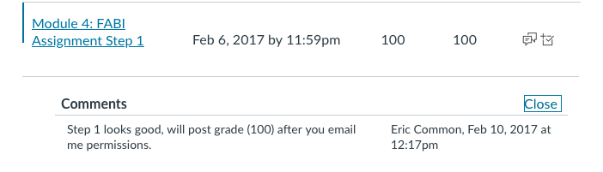
Completion Checklist
Step 1: Identifying students who need a FABI

School: | NRH | District: | ILT | Date: | 2/5/2017

Team Members:

1. | Robin Renee Hogan | 5. | Megan Gregory
2. | Courtney Barrett | 6. | Click or tap here to enter text.
3. | Victoria Corte | 7. | Click or tap here to enter text.
4. | Leteia Schwander | 8. | Click or tap here to enter text.

Coach: | Eric Common

Step 1: Identifying students who need a FABI
Directions: Complete step one, see notes in RED.

 | Check when completed | Item
Estimated Time: 1 week  Start Date: 2/8/2017  End Date:_ 2/19/2017 | X | Communicate with parents and secure permission to conduct the Functional Assessment-based intervention (use your district procedures and forms for subsequent students).  *For SPED 743, turn in signed principal/director, teacher/facilitator, parent, and student permission forms (on University of Kansas [KU] letterhead) for project case to instructors. Do not post in Canvas.  Click or tap here to enter text.
 | X | Talk to the student to answer questions (assent according to your district procedures).  Click or tap here to enter text.
 | X | Complete, confirm, and turn in Referral Checklist: Functional Assessment-Based Interventions (HO1).  Click or tap here to enter text.
Considerations for need:
1. | Yes | Does the student’s behavior impede his or her learning or the learning of other? Or, does the student pose a threat to him or herself or others (Drasgow & Yell, 2001)?
2. | Yes | Has the student been non-responsive to other intervention efforts?
3. | Yes | Does the student have multiple risk factors (e.g., harsh and inconsistent parenting or high mobility) making him or her more susceptible to school failure and/or dangerous behavior?
4. | NO | Has the student been (a) placed in an alternative setting for behavior dangerous to him or herself or others (b) placed in an alternative setting for 45 days due to drug or weapons violations? Or (c), has the student been suspended from school for more than 10 days or has that suspension resulted in a change in placement (Drasgow & Yell, 2001)?
*If you answered yes to the first three questions, a FABI may be warranted. If you answered yes to the fourth question, a FABI is mandated by the Individuals with Disabilities Act (IDEA, 2004).

Suggested Readings
- In the Beyond Behavior Special Issue, read in the method section of articles 2-4 to see how these elementary, middle, and high school students were identified as potentially benefiting from a Tier 3 Functional Assessment Based Intervention (FABI).

- Read Chapter 1 in the following book to learn about a functional approach to problem behavior:

Umbreit, J., Ferro, J., Liaupsin, C., & Lane, K. (2007). Functional behavioral assessment and function-based intervention: An effective, practical approach. Upper Saddle River, N. J.: Prentice-Hall.

- Consider reading more about the various systematic screening tools in:

Lane, K. L., Menzies, H. M, Oakes, W. P., & Kalberg, J. R. (2012). Systematic screenings of behavior to support instruction: From preschool to high school. New York, NY: Guilford Press.

Step 1 Tips:
- Make certain Tier 1 efforts are being implemented as planned (with treatment integrity).

- Consider Tier 2 supports prior to beginning with a functional assessment-based intervention (FABI).

- Ensure a systematic approach is used to detect which students may benefit from a FABI to make certain students have equal access to this support.

- Obtain permission from the parent or guardian as well as the student before beginning this process.

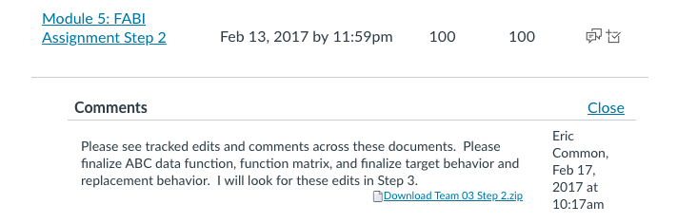
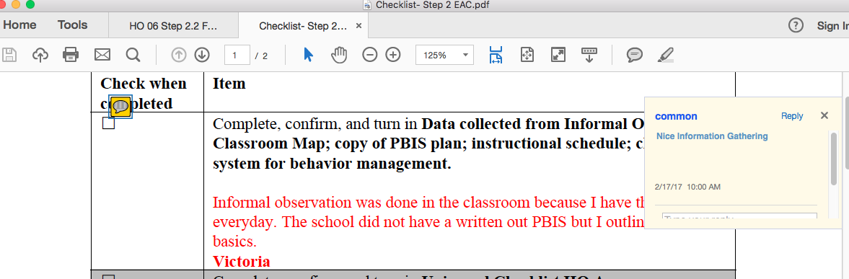
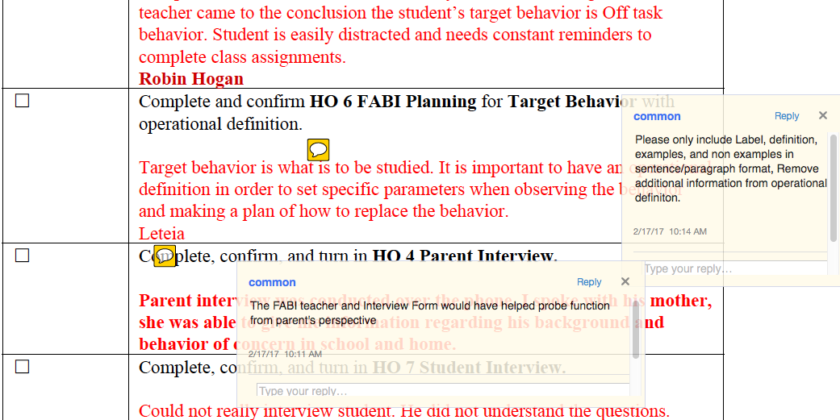
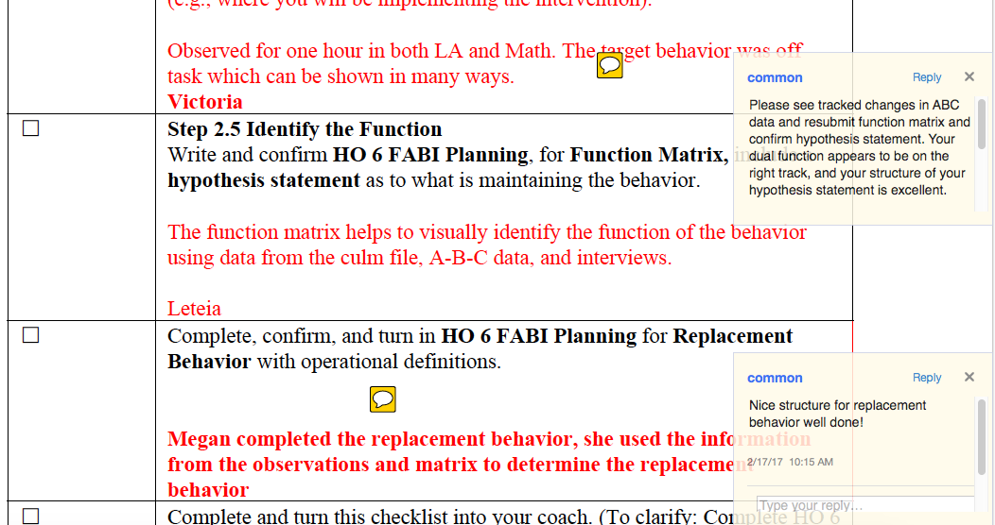
Completion Checklist
Step 2: Conducting the Functional Assessment

School: | NRH | District: | ILT | Date: | 2/12/2017

Team Members:

1. | Robin Hogan | 5. | Leteia Schwander
2. | Courtney Barrett | 6. | Click or tap here to enter text.
3. | Megan Gregory | 7. | Click or tap here to enter text.
4. | Victoria Corte | 8. | Click or tap here to enter text.

Coach: | Eric Common

Step 2: Conducting the functional assessment.

Directions: Complete step two, see notes in RED.
Note: *Shaded rows are not required for SPED 743, but are recommended as regular practices.

Check when completed | Item
X | Complete, confirm, and turn in Data collected from Informal Observation: Classroom Map; copy of PBIS plan; instructional schedule; classwide system for behavior management.  Informal observation was done in the classroom because I have the student everyday. The school did not have a written out PBIS but I outlined the basics.  Victoria
☐ | Complete, confirm, and turn in Universal Checklist HO A.
☐ | Step 2.1 Records Review  Complete HO 2 and 3 SARS Forms.  Click or tap here to enter text.
X | Step 2.2 Interviews  Complete, confirm, and turn in HO 4 Teacher Interview, including operational definition of target behavior.  Completed the teacher interview on Friday, after interviewing the student’s teacher came to the conclusion the student’s target behavior is Off task behavior. Student is easily distracted and needs constant reminders to complete class assignments.  Robin Hogan
X | Complete and confirm HO 6 FABI Planning for Target Behavior with operational definition.  Target behavior is what is to be studied. It is important to have an operational definition in order to set specific parameters when observing the behavior and making a plan of how to replace the behavior.  Leteia
X | Complete, confirm, and turn in HO 4 Parent Interview.  Parent interview was conducted over the phone. I spoke with his mother, she was able to give me information regarding his background and behavior of concern in school and home.
X | Complete, confirm, and turn in HO 7 Student Interview.  Could not really interview student. He did not understand the questions.
☐ | Step 2.3 Rating Scales  Review, confirm, and turn in Social Skills Improvement System – Rating Scale (Teacher Version)
☐ | Review, confirm, and turn in Social Skills Improvement System – Rating Scale (Parent Version).  Click or tap here to enter text.
X  _1_/hours  _8_/instances | Step 2.4 Direct Observation (A-B-C Data Collection)  Review, confirm, and turn in HO 8 A-B-C data (data collection form); write in the number of hours (N = 3) you collected A-B-C and the number of instances (N = 8 minimum) you saw the target behavior occur (Check that data and time are recorded).  *For SPED 743, please conduct a minimum of one hour of A-B-C data. Please remember to complete your direct observation in the setting of interest (e.g., where you will be implementing the intervention).  Observed for one hour in both LA and Math. The target behavior was off task which can be shown in many ways.  Victoria
X | Step 2.5 Identify the Function  Write and confirm HO 6 FABI Planning, for Function Matrix, include a hypothesis statement as to what is maintaining the behavior.  The function matrix helps to visually identify the function of the behavior using data from the culm file, A-B-C data, and interviews.  Leteia
X | Complete, confirm, and turn in HO 6 FABI Planning for Replacement Behavior with operational definitions.  Megan completed the replacement behavior, she used the information from the observations and matrix to determine the replacement behavior
X | Complete and turn this checklist into your coach. (To clarify: Complete HO 6 FABI Planning up to function matrix and hypothesis)  Courtney  After reviewing the checklist and providing feedback to one another, the information was put into a zip file and uploaded.

Suggested Readings
- In the Beyond Behavior Special Issues:
  - Read the first article to learn more about the tools and overall process.
  - Read in the method section of articles 2-4 to see how the functional assessment process was conducted and learn how to complete the function matrix

- Read the following chapters in

Umbreit, J., Ferro, J., Liaupsin, C., & Lane, K. (2007). Functional behavioral assessment and function-based intervention: An effective, practical approach. Upper Saddle River, N. J.: Prentice-Hall.
  - Chapter 2 to learn how to identify the target and replacement behaviors
  - Chapter 3 to learn more about teacher, parent, and student interviews
  - Chapter 4 to learn more about how to collect A-B-C data

Step 2 Tips:
- When defining the target behavior, make certain to include a label, definition, examples, and nonexamples. Also, remember to observe the “dead man’s rule.”

A-B-C data (3 hours; 8-10 instances) are analyzed using the function matrix to determine the reasons why the target behavior occurs.
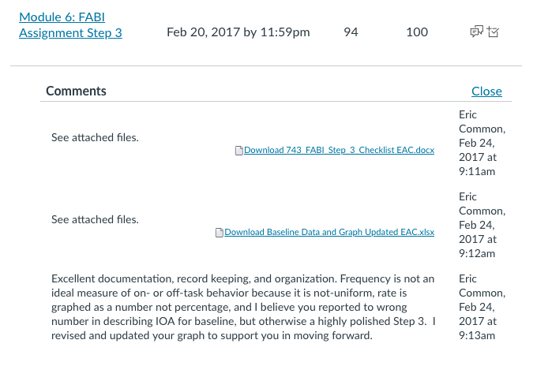
Completion Checklist
Step 3: Collecting Baseline Data

School: | NRH | District: | ILT | Date: | 2/20/17

Team Members:
1 | Victoria Corte | 5. | Megan Gregory
2 | Robin Hogan | 6. | Click or tap here to enter text.
3 | Leteia Schwander | 7. | Click or tap here to enter text.
4 | Courtney Barrett | 8. | Click or tap here to enter text.

Coach: | Eric Common

Step 3: Collecting Baseline Data

Directions: Complete step three, see notes in RED.

Check when completed | Item
X | Complete and confirm through Determining the Function of the Behavior: Using the Function Matrix on HO 6 Planning Sheet.  Click or tap here to enter text.
X | What is the behavioral dimension you are focusing on? (in HO 6 Planning Sheet).  *For SPED 743, write your response here.  Explain here:  Frequency- the rate was calculated after the frequency was collected.  EAC: Frequency recording is not a good measure of on-task or off-task behavior as these are NON-UNIFORM behaviors, refer back to Ch 9 of Umbreit et al for a discussion on uniform or non-uniform behaviors. In brief, these are behaviors that vary in duration, topography, and have unclear boundaries for when the behavior begins and when the behavior ends which makes discrete measurement through frequency recording difficult as it becomes subjective. (-3 points)
X | What measurement system did you select to measure behavior? (in HO 6 Planning Sheet).  *For SPED 743, write your response here.  Explain here:  Event Recording- First it shows the frequency of behavior during the allotted time then you calculate the rate of the behavior.
X | Describe the data collection procedures you will use to measure the behavior: materials needed, data collection sheet, scheduled observation times.  *For SPED 743, write your response here.  Explain here:  With only a week to collect baseline data this allowed for 4 different observation. Data was collected at the same every day during the students Language Arts time.The data collection sheet selected was the event recording sheet. This allowed for frequency and rate to be observed. The materials needs for this were the data collection sheet and a writing utensil. Choosing this method allowed teaching to continue while observing the behavior.
X | How did your team become reliable in data collection?  *For SPED 743, write your response here.  Explain here:  Our team became reliable in data collection through having an obligation to do what is best for the student. We collected all the information as it relates to the the student efficiently. We research the observation techniques we used to observe the student for accuracy. The observation techniques was tested and used on other students a faired to be sufficient with accurate data. EAC: did you set a criterion such as three reliability observations at 85% or higher?
X 4 Sessions | How many reliability data observations were completed? *For SPED 743, write your response here.  There were four reliability data observations.
X 90 % | What was the percent of agreement between observers (interobserver agreement; IOA) on the data collection training (reliability training)?  *For SPED 743, write your response here.  The IOA was conducted on the third observation. Between the two observers the off task behavior was observed by the first observer occurring at least ten times and the with second observer the off task behavior occurred at least nine times. Making the percentage a 90% of agreement between the two observers. For rate and frequency the IOA is determined by dividing the lower reported frequency by the higher reported frequency. Example: 9/10=0.9x 100%= 90%
X 4 data points | How many baseline data points did you collect?  *For SPED 743, write your response here.  For this baseline data, there were four points (four observations) collected. Each observation had various occurrences of behavior. See graphs.
X 1point with IOA | How many baseline data points included IOA (at least 25% of observations)?  *For SPED 743, write your response here.  For this baseline data that included IOA, there was one point (one observation) which is 25% of the total observations. See graphs.  EAC: Excellent
X 25% | What was your IOA for baseline?  *For SPED 743, write your response here.  There were four total observations. One observation (16th) was the IOA observation. The main observer totaled 10 off task behaviors and the second person (IOA) totaled 9 off task behaviors.  EAC: (9/10)*100 = IOA of 90% not 25% (-3 points)
X | Graph your baseline data.  EAC: Please see attached revisions, rate is not graphed as a percentage, I have updated for you.  Attached in ZIP file
X | Complete and turn this checklist into your coach.-  ZIP file includes baseline data, 2nd observer data, graph, and HO 6 Planning Sheet

Suggested Readings
- In the Beyond Behavior Special Issues:
  - Read in the method section of articles 2-4 to see how the behavior was measured (e.g., what dimension? What recording system? How often was reliability assessed) and how people became reliable in the measurement system.
  - In these same articles, review the graphs to see how the data are displayed.

- Read Chapter 9 in the following book to learn how to identify an appropriate measurement system

Umbreit, J., Ferro, J., Liaupsin, C., & Lane, K. (2007). Functional behavioral assessment and function-based intervention: An effective, practical approach. Upper Saddle River, N. J.: Prentice-Hall.

Step 3 Tips:
- Make sure you pick a measurement system that allows you to capture the dimension of interest.

- Be certain to pick a recording system that is feasible, reliable, and stay with the same data collection system in each intervention phase.

- Train with other data collectors before you begin collecting baseline data to be certain the data you are graphing and interpret is truly measuring student performance.

- You will be measuring and graphing the target and/or replacement behavior.
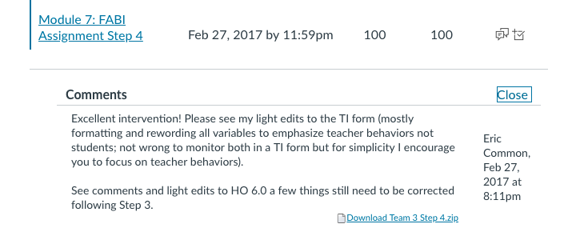
Completion Checklist
Step 4: Designing the Intervention

School: | NRH | District: | ILT | Date: | 2/27/2017

Team Members:

1. | Victoria Corte | 5. | Megan Gregory
2. | Leteia Schwander | 6. | Click or tap here to enter text.
3. | Robin Hogan | 7. | Click or tap here to enter text.
4. | Courtney | 8. | Click or tap here to enter text.

Coach: | Eric Common

Step 4: Designing the Intervention
Step 4: Designing the Intervention
Directions: Complete step four, see notes in RED. Great team work! Super impressed with how responsive everyone is being across steps and working together across the FABI process.

Check when completed | Item
☐ | Step 4.1 Select an Intervention Method  Select Intervention Method and confirm with teacher – HO 6 FABI Planning Leteia  Intervention Method 3: Adjust the contingencies  EAC: This intervention makes sense  .
☐ | Step 4.2 Develop Intervention Components  Draft A-R-E components (Antecedent adjustments, Reinforcement adjustments, and Extinction components)  Link each intervention tactic to the hypothesized function on the planning sheet (depending on the method you select according to the functional assessment intervention decision model). Robin/Leteia  EAC: Thank you for being so receptive to feedback, I am really impressed with your draft  Sent to professor and he suggested to add intervention for the function escaping demand. With his suggestions we added break cards throughout the students intervention so he can take breaks as needed and regroup and return to instruction.
☐ | Step 4.3 Components Related to Valid Inference Making  Draft Treatment Integrity Form including quality rubric HO 11 Treatment Integrity Checklist. Megan  EAC: See feedback below.  See attachments  Plugged in Data from ARE.
☐ | Select and review social validity forms Adapted-IRP-15 and Adapted-CIRP Megan  EAC: This intervention appears to be socially acceptable across stakeholders.  See attachments
☐ | Prepare a plan for introducing the intervention to the teacher – include a check for understanding. Courtney  *For SPED 743, write your response here.  Describe how it was done here:  Instruct the teacher of the examples of non-examples of the replacement behavior. We explained to her to give positive feedback immediately when the student shows on task behavior, explaining to the student “Good Job ---” using specifics. When the student shows off-task behavior, instruct the teacher to use non-verbal cues to promote on-task behavior. We told the teacher to give a gestural prompt such as a tap on his desk every 5 minutes or when she sees fit. We explained the break cards to the students the student gets 2 break cards at the beginning of the class. They are not taken away for off task behavior. If the student does not utilize the break cards then at the end of the week he can trade them in for a longer enrichment activity. We did a check for understanding by having the teacher write a list of non-examples and examples to have as a visual reminder to review before class.  EAC: Clever check for understanding  Click or tap here to enter text.
☐ | Prepare a plan for introducing the intervention to the students – include a check for understanding. Courtney  *For SPED 743, write your response here.  Describe how it was done here:  The teacher plans to pull the student aside before class and privately explain to him what the non-verbal prompt and gestural prompt means. She will explain to him the break system and the expectations when returning from a break. She will review as a whole class as to appropriate on-task behaviors and rules, remind all students to ignore any off-task behaviors or students not following the rules. The plan is to seat the student next to another student that is less-likely show off-task behaviors and who would be a positive model for the student by ignoring the target behavior. To check for understanding, the teacher will review examples and nonexamples with the class. The student will be able to provide verbal examples to the class and the teacher. The teacher will provide additional reminders and positive feedback for on-task behaviors.  EAC: Very respectful training for student  Click or tap here to enter text.
☐ | Revise and finalize A-R-E Intervention Components using feedback from the teacher and draft final TI form HO 11  Robin  EAC: I heavily formatted to try and get it all to fit all one page – if it’s not readable you can increase font size  I reworded everything to be from the teacher’s perspective. Although you are correct in there being teacher-level and student-level components to the intervention plan, this intervention made more sense to monitor the student’s behavior.  Typically when you monitor teacher and student behaviors you have multiple columns for student items and teacher items and total them separately.  Looked over the drafted TI form and made minor changes to HO 11.
Prepare intervention materials Victoria

Prepare break cards and visual of the rules.
☐ | Collect additional baseline data after any school breaks (3 pts.) with at least 1 IOA. Victoria  *For SPED 743, complete this step if a weekend or break from school (e.g., holiday, winter recess) occurs between the last day of baseline (A1) and first day of intervention (B1). You may also continue to monitor baseline and have additional data points while you continue to work through designing the intervention.  Click or tap here to enter text.
☐ | Complete and turn this checklist into your coach. Victoria  Click or tap here to enter text.

Suggested Readings
- In the Beyond Behavior Special Issue:
  - Read the first article to learn more about how to use the Function Based Intervention Decision Model to select an intervention method.

  - Read in the method section of articles 2-4 to see how the Function Based Intervention Decision Model was used to identify an intervention method and how the A-R-E tactics were linked back to the students’ maintaining function of their target behavior.

- Read the following chapters in

Umbreit, J., Ferro, J., Liaupsin, C., & Lane, K. (2007). Functional behavioral assessment and function-based intervention: An effective, practical approach. Upper Saddle River, N. J.: Prentice-Hall.
  - Chapter 6 and 14 to learn about Method 1: Teach the Replacement Behavior
  - Chapter 7 and 15 to learn about Method 2: Improve the Environment
  - Chapter 8 and 16 to learn about Method 3: Adjust the Contingencies
  - Chapter 12 to learn more factors that impact success: social validity, treatment integrity, as well as generalization and maintenance

Step 4 Tips:
- Make sure you have sufficient evidence to answer the two questions constituting the Function Based Intervention Decision Model.

- Align the A-R-E intervention tactics with the maintaining functions determined using the function matrix.

- Make certain all stakeholders are comfortable with the specific A-R-E tactics and have sufficient training and support to put these in place as designed.
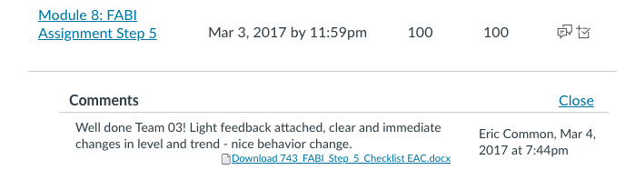
Completion Checklist
Step 5: Testing the Intervention

School: | NRH | District: | ILT | Date: | 3/3/2017

Team Members:

1. | Victoria Corte | 5. | Megan Gregory
2. | Leteia Schwander | 6. | Click or tap here to enter text.
3. | Robin Hogan | 7. | Click or tap here to enter text.
4. | Courtney Barrett | 8. | Click or tap here to enter text.

Coach: | Eric Common

Step 5: Testing the Intervention
Directions: Complete step give, see notes in RED.
Note:
- *Shaded rows are not required for SPED 743, but are recommended as regular practices.
- You may elect to proceed further in the process and withdrawal (B₂), or withdrawal and reintroduce the intervention (A₂-B₂) as time permits.

Check when completed | Item
☐ | Implement Intervention Victoria  Baseline was collected again on 2/27 again and then the intervention was implemented on 2/28. Only 3 days of data were able to be taken because the students had a field trip on Friday. This deadline did not allow for the intervention to be withdrawn.  EAC: Nice reporting and documenting
☐ | Collect Treatment Integrity data daily (teacher perspective) with IOA for 25% of sessions (outside team observer). Victoria  Treatment Integrity was collected the three days of intervention. One day I had my TA Mrs. Edwards collect the treatment integrity to provide IOA.
☐ | Collect Min of 5 data points (behavior measurement – same behavior and measurement system as baseline) – with 25% IOA [Report as number of sessions, % of sessions, and actual IOA %] Victoria  Once step 5 started we only had 3 days to implement the intervention. Because of this we weren't able to withdraw the intervention.  EAC: Nice reporting and documenting
☐  3 data points | How many intervention data points did your collect?  Courtney  There was three different intervention data points. All being conducted during language arts in the morning throughout the week.  EAC: Nice reporting and documenting
☐  1 pts with IOA | How many intervention data points included IOA?  Courtney  There was one data point collected by another observer during language arts class.  EAC: Nice reporting and documenting
☐  80 % | What was your IOA for intervention?  Leteia  For the observation on 3/2/2017 there were two observers. The first counted four occurrences of off task behavior in a 30 minute period and the IOA observer counted 5 occurrences of off task behavior. Using the IOA data calculations for event recording you take the smaller count, divide by the higher count and multiply by 100 to come to the total count IOA percentage.  For this observation that would be 4/5 * 100= 80%.  EAC: Nice reporting and documenting
☐ | Graph your intervention data. (Coaches’ review for support for deciding when to withdrawal the intervention) Megan  The intervention was graphed using a separated XY scatter plot graph. The a graph is the baseline data collected on the student before any changes were made.. The b graph is the intervention data collected on the student once the intervention was taking place. See attached graph to view similarities and differences in behavior before and during intervention.
☐ | Withdrawal of the intervention with at least 3 data points (1 IOA)  *Note phase change decisions for each phase are guided by student performance on variables measured  Click or tap here to enter text.
☐ | Complete Treatment Integrity Form  (daily by interventionist [teacher] 25% IOA)  Click or tap here to enter text.
☐ | Graph withdrawal data  (Coaches’ review for support for deciding when to reintroduce the intervention)  Click or tap here to enter text.
☐ | Reintroduce the intervention.  *Note phase change decisions for each phase are guided by student performance on variables measured  Click or tap here to enter text.
☐ | Collect Treatment Integrity data daily (teacher perspective) with IOA for 25% of sessions (outside team observer).  Click or tap here to enter text.
☐ | Collect min of 3 data points (behavior measurement – same behavior and measurement system throughout all phases) – with 25% IOA [Report as number of sessions, % of sessions, and actual IOA %]  Click or tap here to enter text.
☐ | Plan for follow up data collection to assess maintenance. HO 6 FABI Planning and 6.1 Behavior Intervention Plan (BIP)  Click or tap here to enter text.
☐ | Work with your coaches to complete behavior intervention plan and graphed data to share with teacher and parents Robin/ Victoria  EAC: Nice graph, clear change in level and trend! Congrats on an effective intervention.  Completed HO 6.1- Will be sharing data with the parent next week. As the teacher I want to continue these practices in my class because I saw an increase in on task behavior.
☐ | Conduct final check of ethical considerations HO 14 Ethics Checklist Robin  EAC: Nice job reflecting on the systematic approach we learned to coordinate the FBA and BIP (FABI) to promote desired changes in student behavior while paying attention to these ethical considerations.  Used principles of value to address each ethical consideration. The students needs were addressed based on their individual intervention plan. See attached checklist
☐ | After reviewing final graph, assess POST social validity. Adapted-IRP-15 and Adapted-CIRP Megan  EAC: Nice information gathering and meeting or exceeding stakeholders perceptions of the social importance, social acceptability of the goals and procedures.  After reviewing the final graph, we were able to efficiently assess the post social validity of the intervention. See attachments.
☐ | Complete and turn this checklist into your coach. Victoria  Click or tap here to enter text.

Suggested Readings
- In the Beyond Behavior Special Issues, read the method, results, and discussion section of articles 2-4 to see how the intervention was design, implemented, and evaluated

- Read the following chapters in

Umbreit, J., Ferro, J., Liaupsin, C., & Lane, K. (2007). Functional behavioral assessment and function-based intervention: An effective, practical approach. Upper Saddle River, N. J.: Prentice-Hall.
  - Chapter 10 to learn how to test the intervention
  - Chapter 13 to learn how to monitor the intervention and analyze intervention outcomes

Step 5 Tips:
- Be sure you use an experimental design to make certain you can actually demonstrate a function relation between the introduction of the intervention and changes in student performance.

- Phase changes are determined by examining data (e.g., stability, level, and trend) and are not determined by the amount of time a student spends in each phase.

- Phase changes should not occur before or after breaks in the school year calendar.

- Be certain to collect treatment integrity data with each introduction of the intervention.

- The post-intervention social validity measures are completed by stakeholders after the intervention has been tested and the outcomes (e.g., graph and other data) have been shared with and explained to the stakeholders.

- When you complete HO 6.1, remember it will be used by the current and future teachers. Be certain to include a blank copy of the treatment integrity form for future use as well as a completed graph showing the complete intervention outcomes.

