Link to original assignment: https://prezi.com/b322_ziwtzf3/sped-841-final-project-a-practical-strategies-guide/?utm_campaign=share&utm_medium=copy&webgl=0

Link to presentation: https://ku.voicethread.com/share/9760330/
References:

A Joint Publication of ATIA & SEAT Center. (2006). Assistive technology: Outcomes and benefits. PSU.EDU 3(1). Web. Retrieved from http://research.chem.psu.edu/mallouk/articles/article7.pdf

Agran, M., Sinclair, T., Alper, S., Cavin, M., Wehmeyer, M., & Hughes, C. (2005). Using self-monitoring to increase following-direction skills of students with moderate to severe disabilities in general education. Education and Training in Developmental Disabilities, 40(1), 3-13.

Barth, R.S. (2006). Improving relationships within the schoolhouse. Educational Leadership, 53(6), 8-13.

Boettner, B. (2013). Instructional Strategies Motivate and Engage Students in Deeper Learning.: Gain proven teaching strategies that advance students’ creativity, problem-solving abilities and research skills. Web. Retrieved from http://www.sreb.org/sites/main/files/file-attachments/13v06w.pdf

Chen, Xin. (2016). Analyzing productive learning behaviors for students using immediate corrective feedback in a blended learning environment. Computers and education, ISSN: 0360-1315.
Deitz, S. M., Reep, A. G. & Deitz, D. E. D. (1976). Reducing inappropriate classroom behavior of retarded students through three procedures on differential reinforcement. Journal of Intellectual Disability Research, 20: 155-170.

Detter-Schmelz, D. R., Kennedy, K. N., and Ramsey, R. P. (2002). Enriching our understanding of student team effectiveness. Journal of Marketing Education, 24 (2), 114-124.

Dugan, L. Millborne, S. Campbell, P., Wilcox, M. (2004). Evidence Based Practice in Assistive Technology, Research Brief Volume 1, Number 5. Tots n Tech Research Institute. Available from: http://tnt.asu.edu

Fisher, D. (01/2012). Middle school journal: Building and activating students’ background knowledge: It's what they already know that counts teachers must assess and build on the background knowledge students possess National Middle School Association. doi:10.1080/00940771.2012.11461808

Fitzgerald, G. E. (1996). Journal of research on computing in education: Empirical advances in technology-assisted instruction for students with mild and moderate disabilities. The Association.

Friend, M. (2008). Co-teaching: A simple solution that isn’t simple after all. Journal of Curriculum and Instruction, 2(2).

Grady, W. (2011). The importance of early childhood literacy. WEB. Retrieved from http://www.nationalreadingcampaign.ca/the-importance-of-early-childhood-literacy/

Hargreaves, A. (2007). Five flaws of staff development and the futures beyond. Journal of Staff Development, 28(3), 37-38.

Horn, M. B., & Staker, H. (2014). Blended: Using disruptive innovation to improve schools. John Wiley & Sons.
Horner, R.H., Carr, E.G., Strain, P.S. et al. J Autism Dev Disord (2002) 32: 423. https://doi.org/10.1023/A:1020593922901

Hume K, Loftin R, Lantz J. J Autism Dev Disord. 2009 Sep;39(9):1329-38. doi: 10.1007/s10803-009-0751-2. Epub 2009 May 9. Review.

Jones, F.(n’d). Beginning the new school year: Bell work. Web. Education World. Retrieved from http://www.educationworld.com/a_curr/columnists/jones/jones020.shtml#sthash.4hNCp15V.dpuf

Kagan, S., & Kagan, M. (2009, 2015). Kagan Cooperative Learning. San Clemente, CA: Kagan Publishing.

Krech, M. (2012). Science teaching ideas. Web. MJ Krech. Retrieved from http://mjksciteachingideas.com/pdf/STITutorial11.pdf

Kregenow, J.M., Rogers, M., & Price, M.F. (2011). Is there a “back” of the room when the teacher is in the middle?. Journal of College Science Teaching, 20(6), 45-51.

Kurtts, S.A. (2006). Universal design for learning in inclusive classrooms, Electric Journal for Inclusive Education, 1 (10).

McKendall, M. (2000). Teaching groups to become teams. Journal of Education for Business, May/June, 277-282.

Moore, D. (2008). Reading comprehension strategies. Retrieved from http://ngl.cengage.com/assets/downloads/edge_pro0000000030/am_moore_read_comp_strat.pdf

Pisha, B., & Coyne, P. (2001) Smart from the start: The promise of universal design for learning. Remedial and Special Education, 22(4), 197-203.

RAND Reading Study Group. (2002). Reading for understanding: Toward as R&D program in reading comprehension. Santa Monica, CA: Science and Technology Policy Institute, RAND Education.

Rapposelli, J. (2004). Blended learning provides pathway to success for high school students. The Journal. Web. Retrieved from https://thejournal.com/articles/2014/10/22/blended-learning-provides-pathway-to-success-for-high-school-students.aspx

Robertson, K. Connect students' background knowledge to content in the ELL classroom. Colorin Colorado. Web. Retrieved from http://www.colorincolorado.org/article/connect-students-background-knowledge-content-ell-classroom

Rose, D.H., & Meyer, A. (2002). Teaching every. student in the digital age. Alexandria, VA: Association for Supervision and Curriculum Development

Steffensen, M., Joag-Deve, C., & Anderson, R. "A Cross-Cultural Perspective on Reading Comprehension". Reading Research Quarterly, 15 (1), (1979: 10-29.

Wannarka, R., & Ruhl, K. (2008). Seating arrangements that promote positive academic and behavioural outcomes: a review of empirical research. Support For Learning, 23(2), 8993.

Feedback:
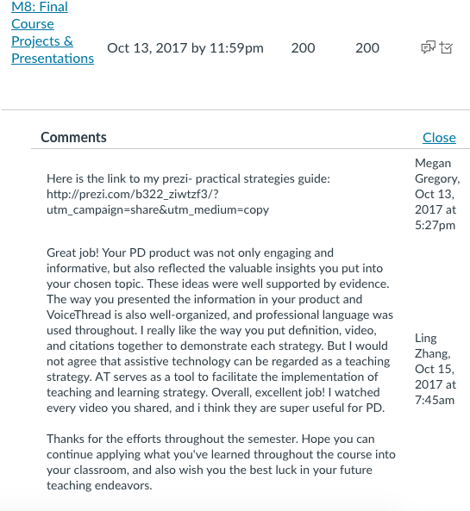
Assignment description:
Final Project

The purpose of this assignment is to encourage a deeper understanding of individuals with disabilities, how to best support these learner differences, and how to use your Just In Time (JIT) learning skills. A secondary purpose is to encourage your growth as a young professional, in your ability to problem-solve, locate solutions, and apply research to practice. You will have the opportunity to choose from one of the following projects.

1.Practical Strategies Guide
2.What is a Modern Educator?
3.Traditional Paper
4.Single Individual or Small-Group Intervention
5.Class-Wide UDL Implementation Project
6.Explore & Build an Instructional Product of Your Choosing
7.Virtual/Blended Instructional Unit

For project descriptions and grading expectations, access Module 0 “Succeeding In This Course” on KU Connect.

Rubric:

Grading Rubric- Megan Gregory

 | Unsatisfactory  (1) | (3) | Satisfactory  (2) | (4) | Exceeded  (5) | Weight
Content or Required Elements  Including:  • Project-specific requirements  • APA citations/  reference list,  • VoiceThread,  • Self-graded rubric) | The project was missing required elements. |  | Based on the selected project, the required elements were visibly present. |  | The project exceeded the required  elements in multiple ways. | 50%
Creativity | The final product and associated content lacked original thought, insight, or ideas. OR  The ideas presented lacked value to the field of practice. AND/OR  Past research was generally overlooked in supporting the development of the product and associated content/ideas. |  | The final product and associated content demonstrated original thought, insight, or ideas that would be of value to the field of practice.  These ideas were generally interlinked to research.  Generally, the intended audience would find the product and content engaging and of some value. |  | The final product and associated content exceeded expectations in original thought, insight, or ideas that would be of value to the field of practice.  These ideas were directly interlinked with well-supported evidence.  The intended audience would find the product and content engaging and of some value. | 10%
Presentation | Final product was lacking in organization and/or creativity (including information and visual organization) needed to  provide a professional presentation. |  | Final product communicated information effectively and met criteria expected from an entry-level educator.  Communicated clearly to audience. |  | All areas of the product exceeded expectations in terms of how information was communicated and presented.  It was designed to generally enhance the viewers’/grader’s understanding. | 10%

 | Unsatisfactory  (1) | (3) | Satisfactory  (2) | (4) | Exceeded  (5) | Weight
Professionalism | Non-professional language was used.  Descriptions and examples lacked understanding.  Non-person-first language was used, contained multiple errors.  Contained non- flowing or awkward sentence structure. |  | Professional language was used throughout.  Descriptions and examples were  given that enhanced understanding.  Contained no to only a few minor errors.  Language usage was varied in sentence structure and used field- based terminology. |  | Professional language was used throughout.  Descriptions, examples, and references to previous professional/pre-  professional teaching experience and scholarly sources showed insight into subject matter and enhanced understanding.  Was essentially error-free.  Sentence structure was varied.  Used field-based terminology that enhanced understanding. | 20%
Use of Sources | Sources of information were lacking and/or could have used more attention. |  | Sources of information and data were appropriate for the project and as expected.  Use of sources met the criteria of the assignment |  | Sources of information and data exceeded expectations in at least two or more of the following ways:  • Number of sources,  • How sources were integrated into the project,  • How sources were use to  demonstrate understanding of content,  • How sources were used to communicate to the reviewer/ audience. | 10%

