Megan Gregory
13 November 2017
SPED 843
M3T2
Assignment on Analyzing an Existing Student’s Program for Effectiveness
For this assignment, I will be conducting an analysis of an existing student’s program for effectiveness. I will discuss the essential and salient characteristics of the program such as the professionals involved, community support, environmental supports, behavior management systems, social skill and interaction programs, academic support systems, as well as parent and family involvement programs. The student (pseudonym: Keaton) has been diagnosed with an Emotional and Behavior Disorder (EBD) and his school created the following described program to meet his specific needs. Along with Keaton’s program making use of Response to Intervention (RTI) supports, his program possessed specific qualities that overall made it extremely effective.
Let us begin with the qualified and committed professionals involved, since I have learned that they are the most important factor in the effectiveness of programs and outcomes. For this particular available program, the professionals involved were the general education teacher, paraprofessional, special education teacher, parents, principal, and school counselor. Such educators and personnel need to be well versed in the basic foundations of general and special education pedagogy. They also need to have specialized skills related to the instruction of students with significant emotional, social, and behavioral problems such as Keaton. This team of professionals had this knowledge and skills so they were well qualified and committed, which leads me to make the first mark for the effectiveness of this program.
Utilitarian environmental supports are another aspect to analyze. I have researched classroom conditions that should be in place to facilitate instruction. These conditions are but not limited to the following: established behavioral expectations (posted class rules); consistent rule monitoring (by the teacher); feedback and positive corrective actions (peer and teacher); schedules and routines (also posted); appropriate physical environment (seating as well as learning materials); and suitably designed space for learning and social activities (centers and organization). To support Keaton and his entire class, the two teachers and paraprofessional made sure to provide these appropriate environmental supports such as classroom atmosphere, seating arrangements, centers, and posters of class rules and schedule. I witnessed how consistency of all of these is key to a successful support system. Since these supports were apparent and available, this is another way the student’s program was effective.
To further analyze the effectiveness of Keaton’s program, I will discuss the behavior management programs in place. In this module and from the readings, I learned how positive and encouraging support works best compared to punishments and zero tolerance policies. Proactive methods such as those that consider both group and individualized behavioral supports (integrated within a system of school-wide and classroom level supports) seem to be more effective when facilitating improved student outcomes and student engagement. This particular program integrated organization and structure, multi-tier positive behavioral supports (RTI as mentioned and PBIS- Positive Behavioral Interventions and Supports), as well as Applied Behavior Analysis (ABA) for management, and Functional Behavior Analysis (FBA) for data based analysis. From this, a Behavior Intervention Plan (BIP) was also created. Seeing these in action ensure that Keaton’s program was effective. Moreover, I learned that prevention is just as important as reaction.
Another aspect of an effective program is the social skill and social interaction training components. Social skill curriculum includes general social skills training with additional focus on social skill acquisition deficits, social performance deficits, and the appropriateness of responses. Keaton’s program focused on three parts: social skill acquisition, social performance, and social fluency. They used social stories for Keaton to transfer and generalize social skills so that he would have the opportunity to use and practice in real-world situations. His educators were also models of his desired behavior that not only taught Keaton but also taught all other students. Video clips on rule following and waiting to talk as well as coping strategies (counting to 10, deep breathing) were infused to Keaton’s skill set. His particular program integrated routes that provided individualized aspects in regards to peer characteristics as well as social demand that, again, support that this program was effective.
Further, another component of an effective program is the academic support systems in place. Academic supports include carefully orchestrated instructional time, specific instructional targets and systematic evaluation, and instruction matched to individual learning style and primary modality; assessment and progress monitoring; and programming for opportunities to respond. Keaton required additional support in reading and writing, so his teachers made sure to provide literacy support as needed. By providing focus groups (centers focusing on phonemic awareness, phonics, alphabet instruction, fluency, vocabulary, and comprehension) Keaton received the instruction he needed to be successful. They also integrated peer tutoring, peer-assisted learning strategies, and peer reinforcement as well as peer-mediated interventions (self-monitoring, goal setting, and so forth.) These characteristics further made Keaton’s program effective.
Next is the parent and family involvement programs. This area can be one of the most difficult components to establish. Communication between teachers, staff, and families is what can make or break a student program. I know that school efforts facilitate parental involvement such as inviting and including them in information exchanges such as IEP meetings and other sessions. Additionally, I have learned that in order to create a solid program in this area we need to focus on what the parents might need, like emotional support, coping skill training, and stress reduction training. Keaton’s program included these supports and trainings by creating a partnership with his parents who were very eager to be as involved as they could. Further, Keaton’s parents were involved with not only attending and participating in meetings, they also modeled appropriate behavior at home and practiced these skills with Keaton. It was this recognition of behavior and provision of positive feedback that really developed the family component of Keaton’s program making it an even more effective system.
Keaton’s program also had coordinated and effective community support programs. I have learned and research supports that students with EBD need supports that go beyond the scope of what schools can provide. I have also learned that schools can work to help coordinate these services. Keaton’s program and people involved made sure to provide affordable support, counseling, and advocacy services. His community also had recreation activities willing to accommodate special need youth, economic and social support programs, and agencies that can act as a gateway to other state and federal supports. I witnessed yet another component of Keaton’s program that ensured it was effective.
Overall, the final component of an effective program is how educators infuse ongoing evaluation throughout the programming. Ongoing assessments and reviewing of a student’s progress is crucial since it shows us how the student is actually doing and if he is responding to the programs. Keaton’s program allowed for weekly progress monitoring, self-checks, behavior assessments such as the Conners Parent and Teacher Rating Scales and the Behavior Assessment System for Children, and also regular meetings with and without the student to assess how Keaton was doing (discussing IEP and BIP). Through classroom structure and environment, collaboration, teacher care, behavioral strategies, instructional strategies, and social skill training, Keaton’s program was well rounded and addressed all aspects of his life and educational experiences. To bring this analysis to an end, Keaton’s program certainly met the qualifications in each area that make it effective and essentially help Keaton become successful individual in and out of the classroom.

Feedback:

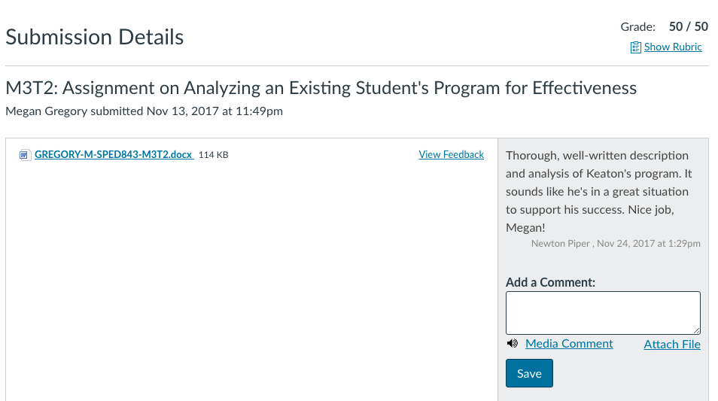

Assignment description:

Instructions
Think about a student you have known or worked with in the past. Conduct an analysis of that student’s program using the elements of an effective program presented in this module and described in the Simpson, Peterson, and Smith (2011) reading.

Guidelines
Your assignment should be between four to six pages in length and will be assessed on the following:
- A clearly written description of the subject; essential and salient characteristics of the program described.
- A brief description and analysis of the availability of qualified and committed professionals.
- A brief description and analysis of the availability of utilitarian environmental supports.
- A brief description and analysis of the availability of an effective behavior management program.
- A brief description and analysis of availability of effective social skill and social interaction support programs.
- A brief description and analysis of effective academic support programs.
- A brief description and analysis of the availability of effective parent and family involvement programs.
- A brief description and analysis of the of the availability of coordinated and effective community support programs.
- A brief description and analysis of the of the availability of ongoing and effective program evaluation.

Rubric
M3T2 Assignment Rubric
M3T2 Assignment Rubric
Criteria | Ratings | Pts
This criterion is linked to a Learning OutcomeClearly written description of the subject; essential and salient characteristics of the program described |  | 5 / 5.0 pts
This criterion is linked to a Learning OutcomeBrief description and analysis of the availability of qualified and committed professionals |  | 5 / 5.0 pts
This criterion is linked to a Learning OutcomeBrief description and analysis of the availability of utilitarian environmental supports |  | 5 / 5.0 pts
This criterion is linked to a Learning OutcomeBrief description and analysis of the availability of an effective behavior management program |  | 5 / 5.0 pts
This criterion is linked to a Learning OutcomeBrief description and analysis of availability of effective social skill and social interaction support programs |  | 5 / 5.0 pts
This criterion is linked to a Learning OutcomeBrief description and analysis of effective academic support programs |  | 5 / 5.0 pts
This criterion is linked to a Learning OutcomeBrief description and analysis of the availability of effective parent and family involvement programs |  | 5 / 5.0 pts
This criterion is linked to a Learning OutcomeBrief description and analysis of the of the availability of coordinated and effective community support programs |  | 5 / 5.0 pts
This criterion is linked to a Learning OutcomeBrief description and analysis of the of the availability of ongoing and effective program evaluation |  | 5 / 5.0 pts
This criterion is linked to a Learning OutcomeAccurate spelling and grammar |  | 5 / 5.0 pts
Total Points: 50

