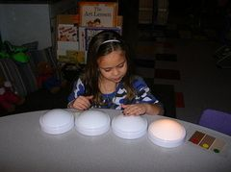
Activity One: Phonemic Awareness with Lights
This activity is somewhat similar to the popular phonemic awareness activity of Elkonin Boxes or sound boxes. The student is given a number of touch lights. As the student says the word, they turn on a light for each sound they hear in the word. Leaving the lights on, they say the word again this time turning off a light for every sound they hear. They should turn on and off the same amount of lights for each word. This is best used in small groups utilizing 1 to 4 phoneme words.
This is a great activity for Phonemic Awareness first and foremost because it involves only sounds and no letters, which as previously discussed is a requirement to be considered phonemic awareness. Second, it allows students to see a visual representation for each of the sounds as they hear them, as well as provides them a means to double check themselves (turning the lights back off). This activity allows students to really experiment with what sounds they are hearing as well as isolating sounds . Having them turn lights on and off also provides an easy check for the instructor to see if they have heard the sounds correctly by looking at how many lights they illuminated.
Activity retrieved from: www.pinterest.com
Original Author: www.readingresource.net/phonemicawarenessactivities.html

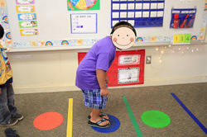
Activity Two: Phonemic Awareness for Kinesthetic Learners
This activity focuses on helping students isolate the sounds in a word, but could also be used for syllable learning later on. Assemble dots and lines on the floor using multicolored duct tape. The students hope from dot to dot as they segment each sound in a word. This activity encourages students to hear every sound in the word, as well as gets them out of their seats (which we know everyone loves to do). This would be a great activity to use in centers if you do centers in your classroom.
Again, this activity is great because it involves only sounds and letters. I really enjoyed it because it involved activity and motion, two things that I know kids love and it could be easily adapted to other purposes. Students are given an opportunity to hear the sounds and physically represent them cementing their knowledge and understanding of the concept.
Activity retrieved from: www.pinterest.com
Original author: http://mrsriccaskindergarten.blogspot.com

Both of these activities were retrieved from Whitnee Raines (whitneejanae.weebly.com)

