Sound Bingo
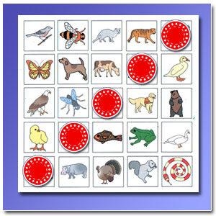
Materials:
- Game board laid out on a 5x5 grid containing Picture cards of simple images. You can useView2do, or print out our free picture cards from the site.
- Chips or Checkers
To Play:
Each player has his or her own board.
Tell each player to cover up all the pictures on his or her board that start or end with a particular sound. For example, say "Cover up all the pictures that begin with a 'c' sound", or "Cover up all the pictures that end in a 'b' sound."
Use consonants, not vowels, for kids at this level of learning.
When a player gets 5 chips in a row (horizontally, vertically, or diagonally) he or she calls out "Bingo!" and wins the round.

