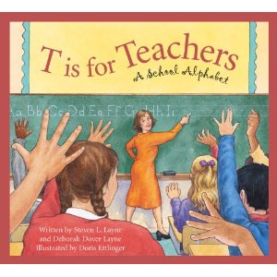
Activity One: Creating Content Area ABC Books
This activity is on that could be used in grades 6 through 8. The best way for students to learn any skill is in context, and vocabulary is no different. This activity gives students a way to use vocabulary in context, integrate art and creativity, as well as review a content area. Students will create their own ABC book using vocabulary from a specific content area. After introducing the class to the concept through read-alouds and discussion, students will break into small groups to create their own ABC book. Each group will decide the style and structure of their book as well as picking a word from their content area textbook for each letter. After creating a storyboard with each letter and illustration for each page, students will construct their final ABC book. Not only do students get to take an active role in selecting and learning the vocabulary, they also build their research skills through the exploration of this vocabulary and demonstrating this knowledge in their finished books. This activity allows students to really explore vocabulary in context and engage with it on a deeper level. The link below has resources for organizers, sample ABC books, and online book formats for the finished product.
Activity retrieved from: http://www.readwritethink.org/classroom-resources/lesson-plans/bookmaking-builds-vocabulary-content-276.html

Activity Two: 10 Important Words
This is a strategy you could use to help students learn vocabulary in context as well as help them transfer this knowledge over into other contexts. The teacher selects a piece of text for the class to read together. As the read through the piece, students select 10 words they believe are important to the piece and record them each on a sticky note. This is done individually without speaking to other students. When everyone has read the piece and selected their 10 words, the class comes together and records the words students selected as important on a bar graph. Students then look up the definitions of these 10 important words and write sentences that summarize the content of the definition. Students will then write several sentences using the 10 important words in different contexts.
This activity is good for building activity, first because students are able to select which words they deem important whether it is because they did not recognize it or for other reasons. This helps them to self-monitor and allows them an opportunity to learn words that they deem as valuable. This activity also allows students to learn how to find word definitions and how to use words in different contexts.
Activity Retrieved From: http://www.readwritethink.org/professional-development/professional-library/important-words-plus-strategy-20942.html

These activities were retrieved from Whitnee Raines weebly.

